CSE 241 OOP HOMEWORK 1 PRESENTATION DOCUMENT
In this pdf document you will find explanations of the homework I did, lines of code, Uml table of classes and many explanations.
Description of code fragments:
main.cpp:
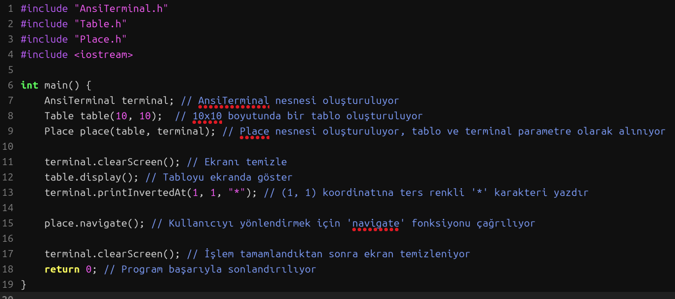
As you can see above, in the main.cpp file, you can see the code that creates the table and gets the number of rows and columns of the table. As a result, we create the table and get the number of rows and columns using other .h libraries in the main.cpp file.
Cell.h:
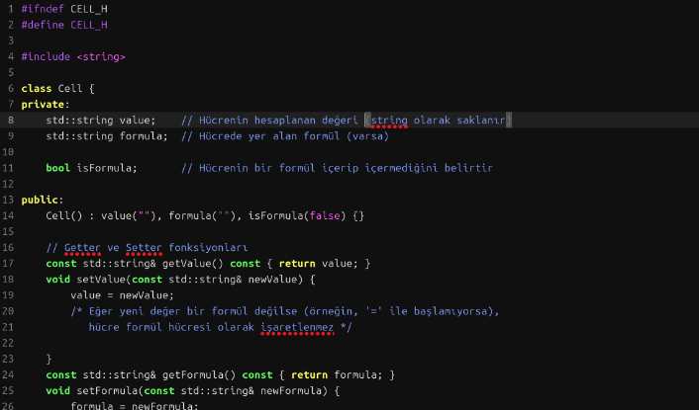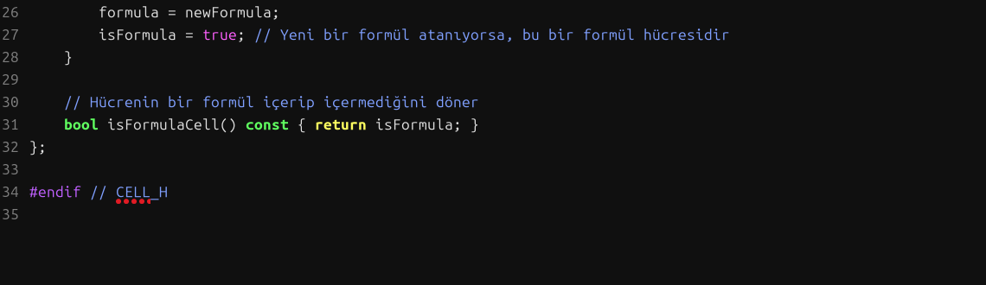
Since the Cell.h file is short, we did not need to create a .cpp file, we did the implementations directly in the file.
This file defines a Cell class representing a cell in a spreadsheet. The class contains the following:

Private Attributes:

value: Stores the calculated value of the cell as a string.
formula: Stores the formula inside the cell, if any.
isFormula: A boolean flag indicating whether the cell contains a formula.
Public Methods:

Constructor: Initializes the cell with an empty value, no formula, and sets isFormula to false.
Getters and Setters:
getValue() and setValue(): Retrieve and set the value of the cell.
getFormula() and setFormula(): Retrieve and set the formula of the cell. If a formula is set, the cell is marked as containing a formula.
isFormulaCell(): Returns a boolean indicating whether the cell contains a formula.
This class allows handling both regular values and formulas in a cell, while distinguishing between the two.
Table.h:
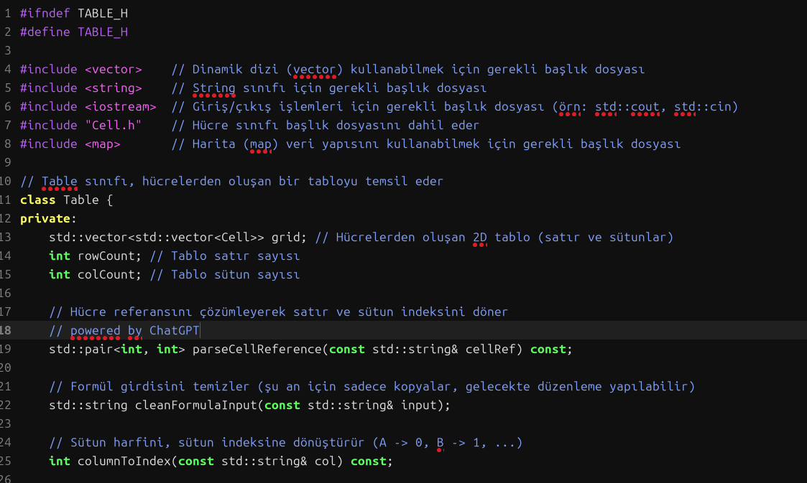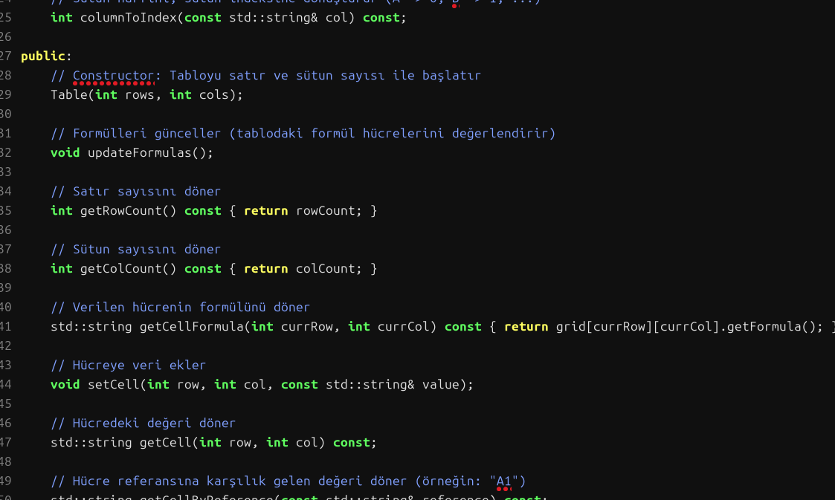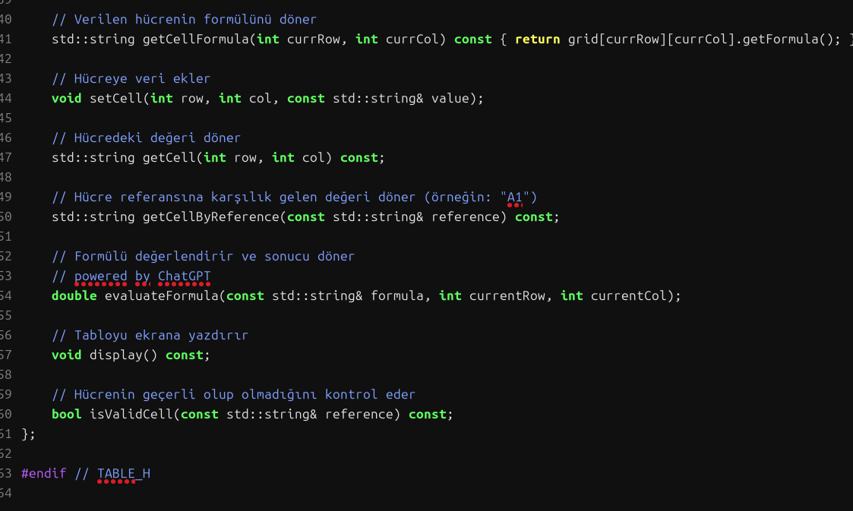
This file defines a Table class representing a spreadsheet:
Attributes:
grid: A 2D vector of Cell objects.
rowCount and colCount: Store the number of rows and columns.
Methods:
Constructor: Initializes the table with specified rows and columns.
updateFormulas(): Evaluates and updates the formulas in the table.
Getters: Returns row count, column count, and cell formulas.
setCell() / getCell(): Set and get cell values.
getCellByReference(): Retrieve cell value by its reference (e.g., "A1").
evaluateFormula(): Evaluates a formula and returns the result.
display(): Prints the table.
isValidCell(): Checks if a cell reference is valid.
The class handles a grid of cells, evaluates formulas, and manages cell references.
Table.cpp:
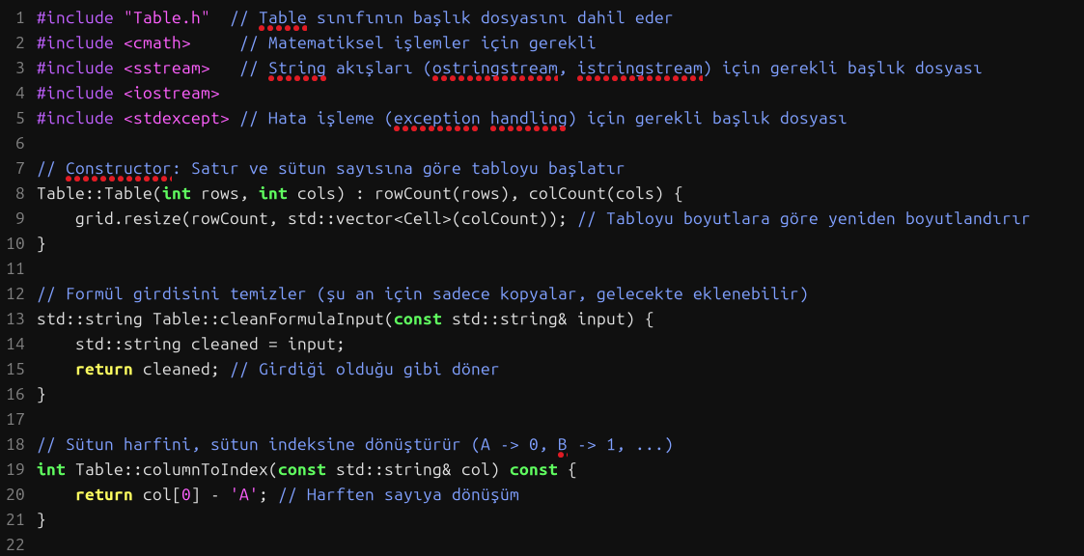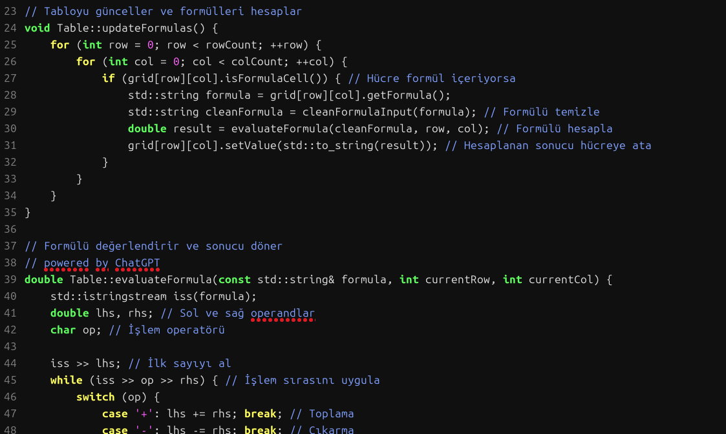
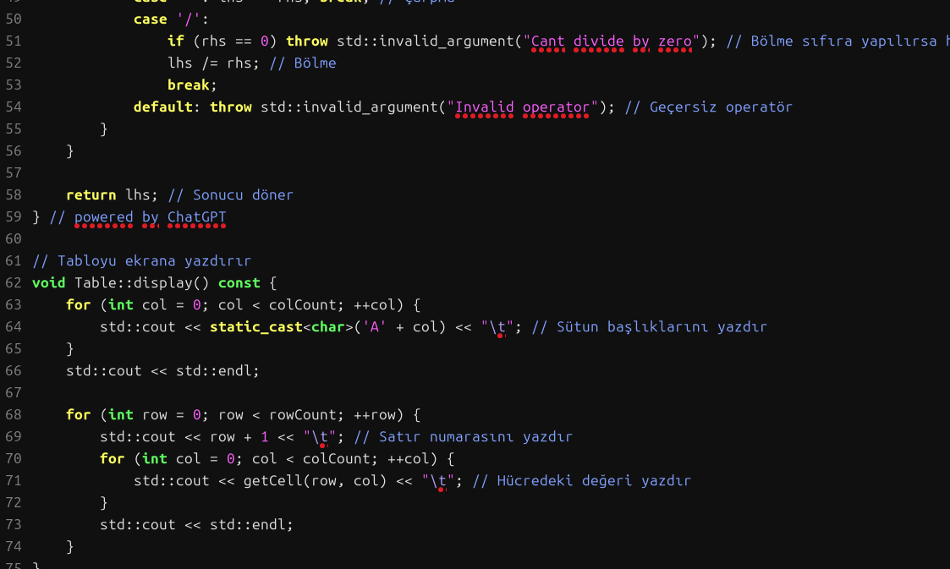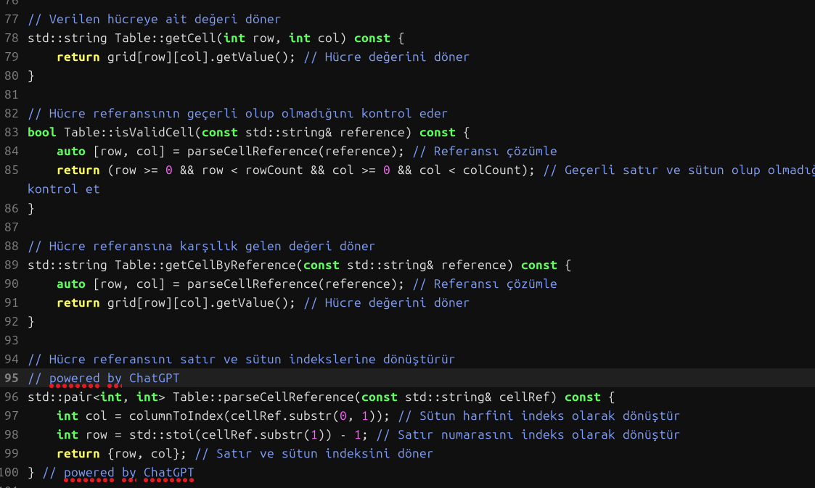
As you can see in table.cpp, table.h has implementations and is supported with comment lines.
double Table::evaluateFormula(const std::string& formula, int currentRow, int currentCol) and
I wrote std::pair<int, int> Table::parseCellReference(const std::string& cellRef) const with help from Chatgpt
Place.h:
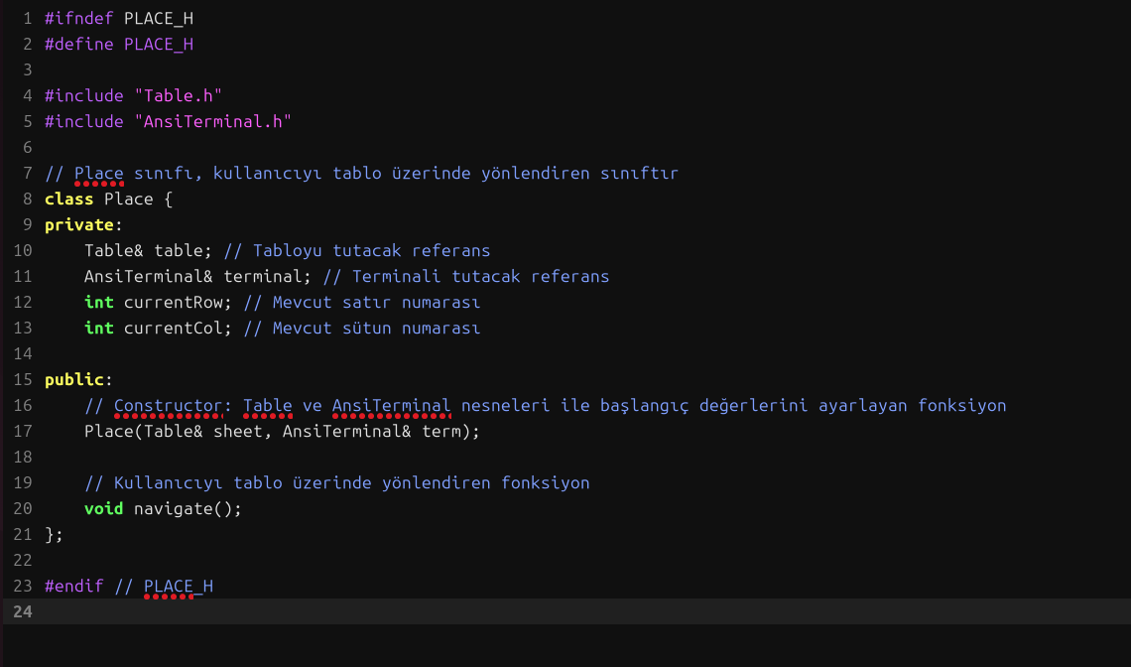
This file defines a Place class that helps navigate a table:
- Attributes:
  - table: A reference to the Table object.
  - terminal: A reference to the AnsiTerminal object.
  - currentRow and currentCol: Store the current position of the user.
- Methods:
  - Constructor: Initializes the table and terminal references.
  - navigate(): Guides the user through the table.
The class facilitates navigation within the table and terminal.
Place.cpp:
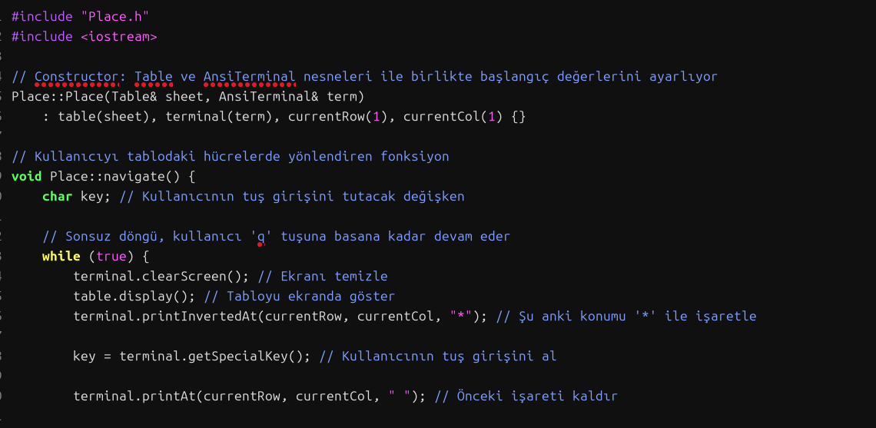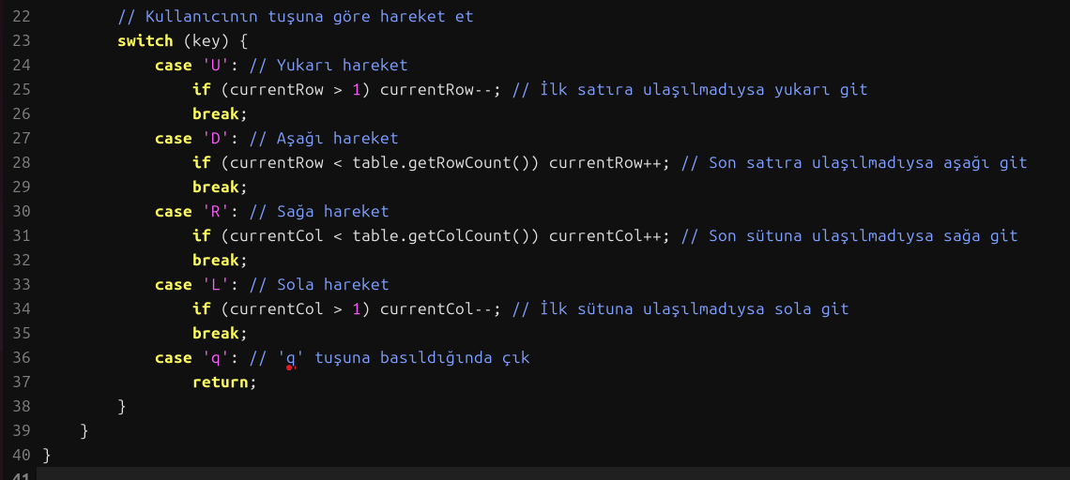
Place.cpp contains the implementation of the place.h file you saw above.

I have written these codes correctly and they work in harmony with each other, but although I have been trying for days, I could not reach the result I wanted in the terminal. I can print the table I want to the terminal, I can navigate between the values in the table, but I cannot get values from the user to the table. You can access the terminal output below.
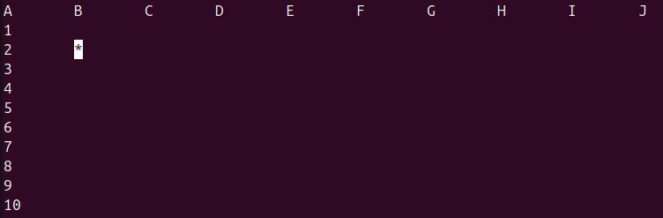
UML Class Diagram:
